DAY 4 CLASSWORK: INTERMEDIATE LEVEL

24.Write a program to concatenate two strings using pointers.

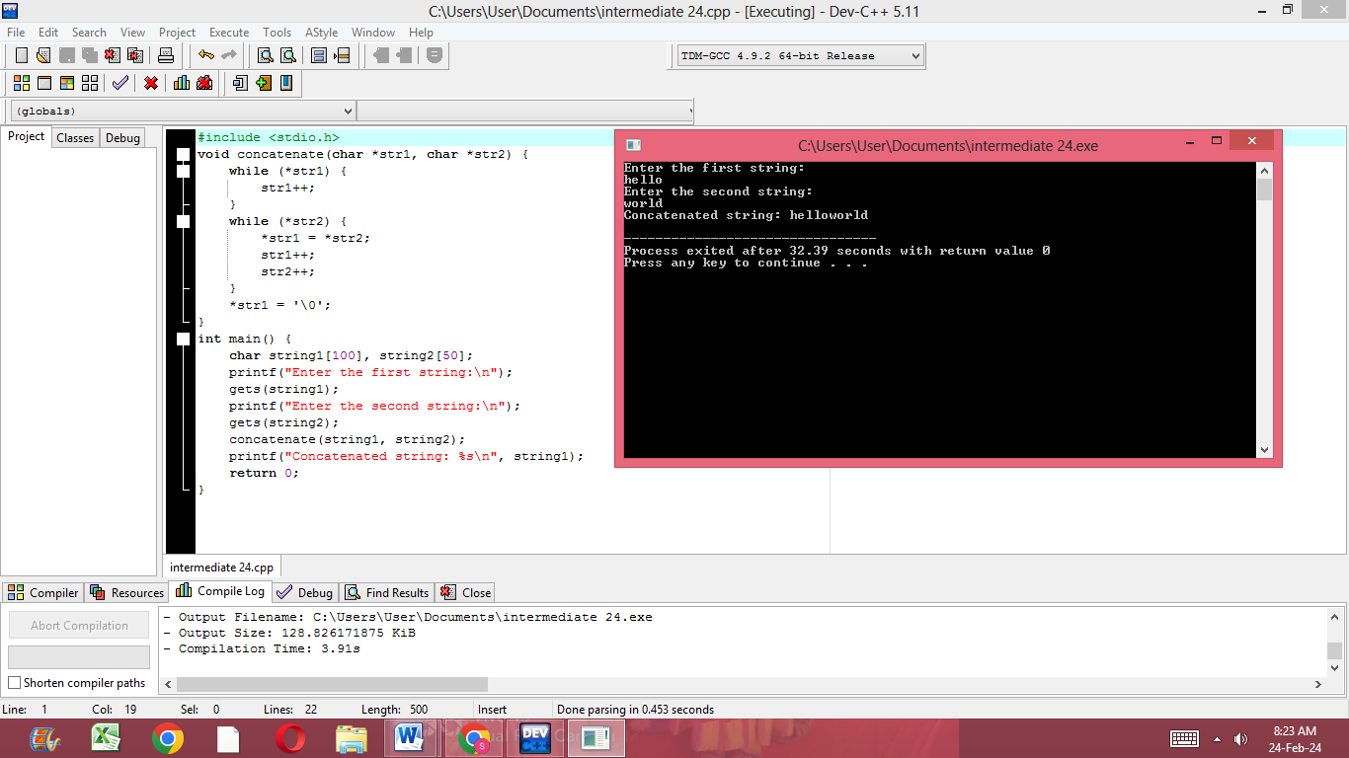

25.Write a program to find the sum of elements in an array using pointers.

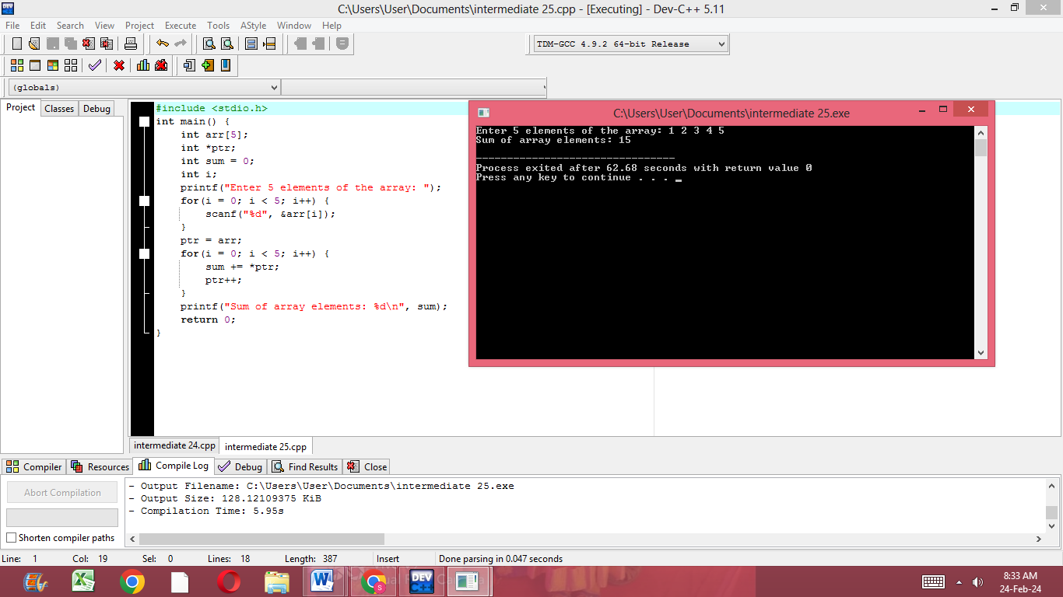

26.Write a program to delete an element from an array using pointers.

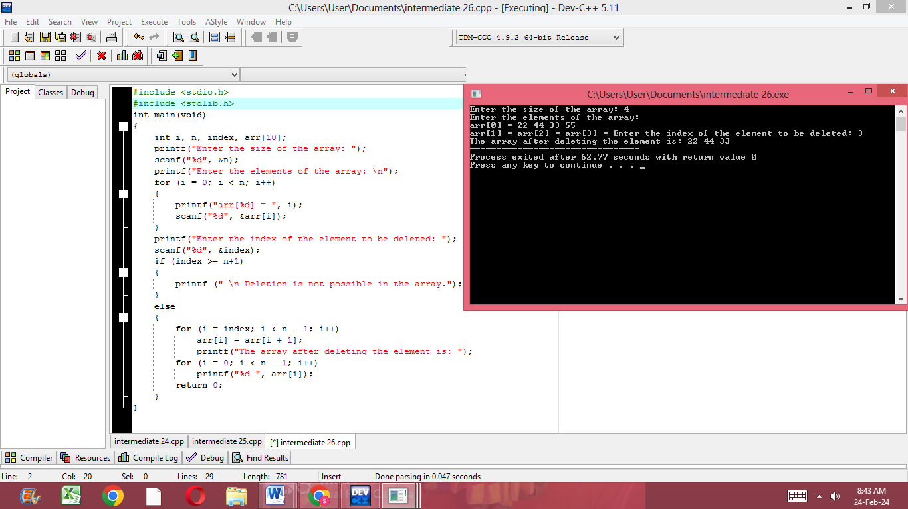

27.Write a program to reverse an array using pointers.

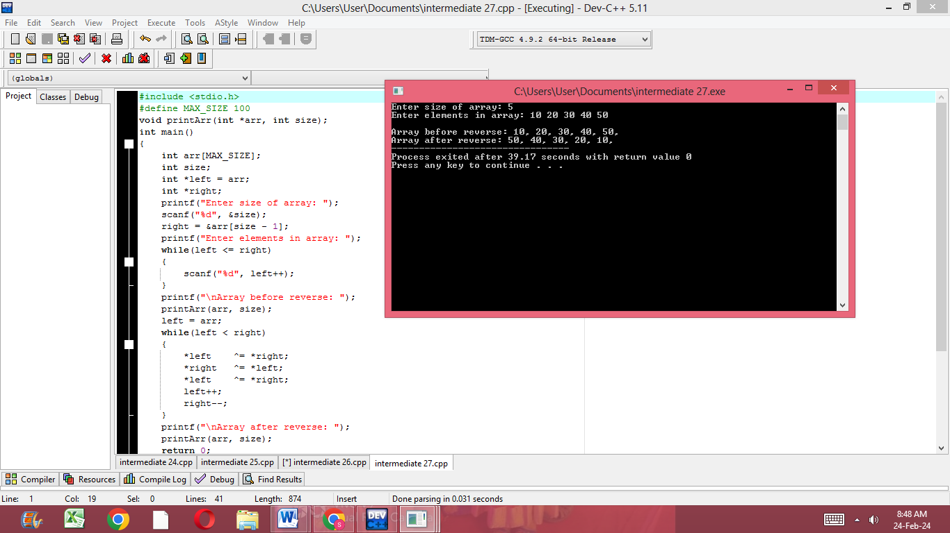

28.Write a program to find the largest and smallest elements in an array using pointers.

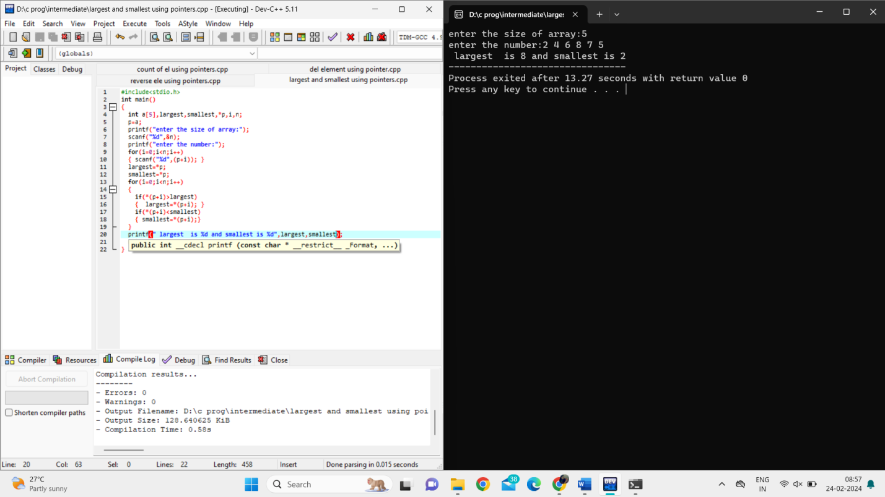

29.Write a program to copy the contents of one array to another using pointers.

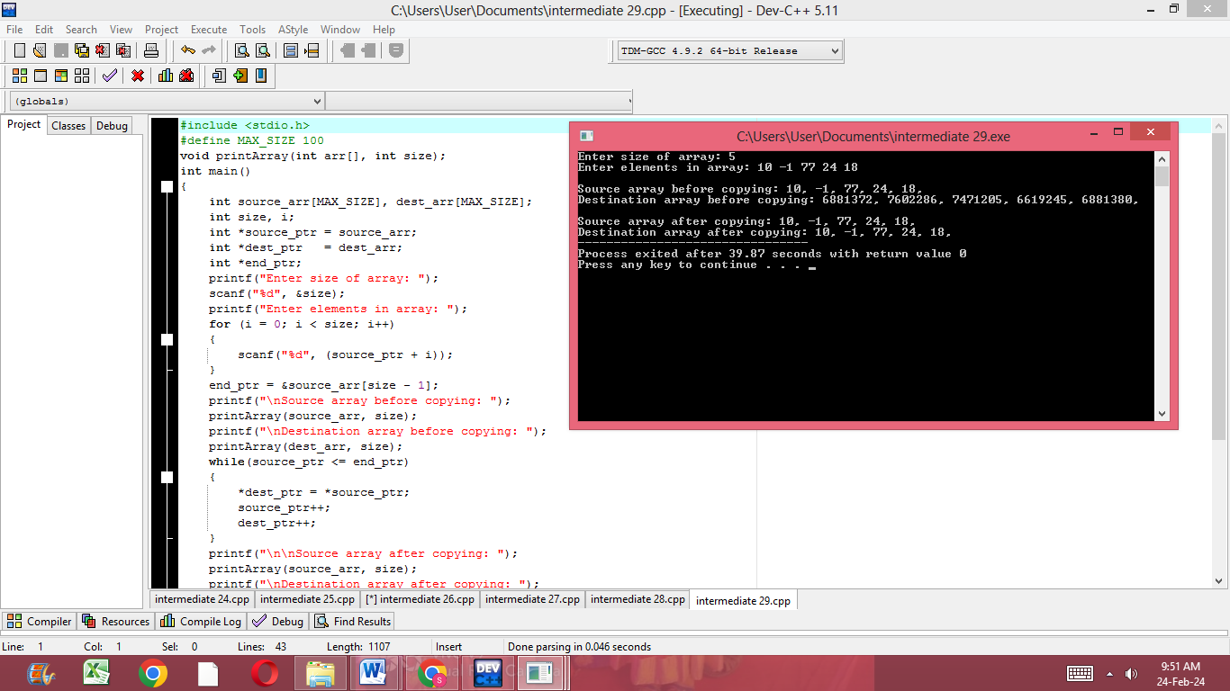

30.Write a program to find the intersection of two arrays using pointers.

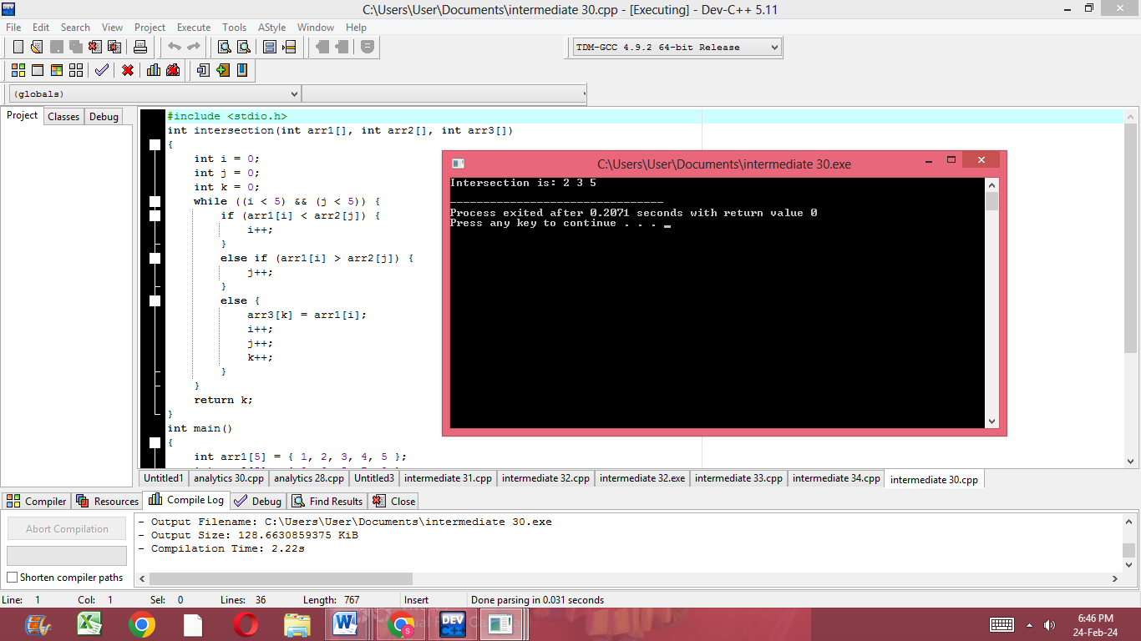

31.Write a recursive program to calculate the factorial of a given number.

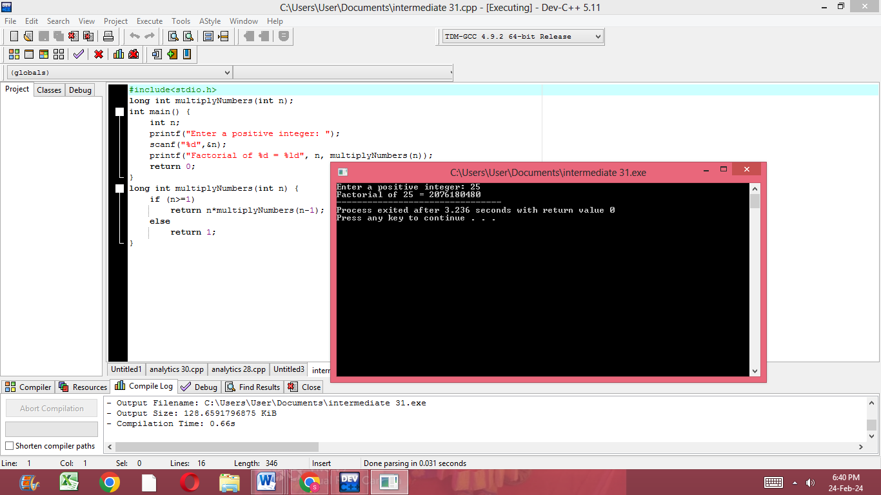

32.Implement a recursive program to find the nth Fibonacci number.

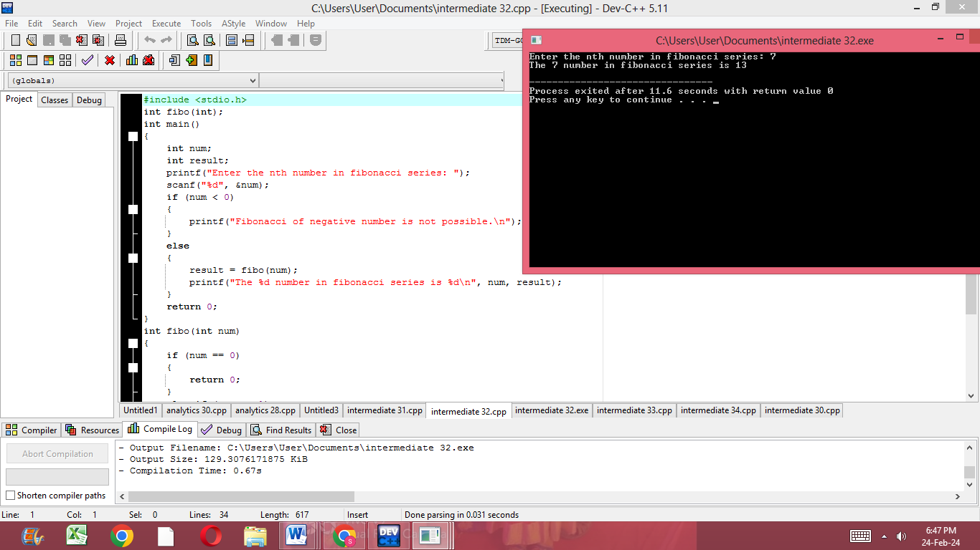

33.Write a program to recursively calculate the sum of digits in a given number.

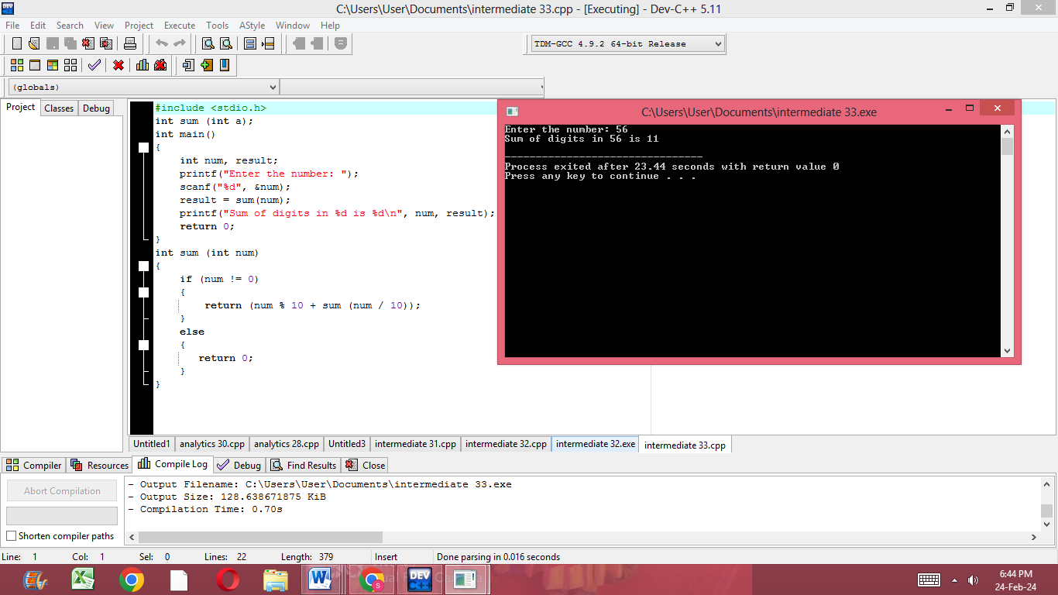

34.Implement a recursive program to calculate the power of a number.

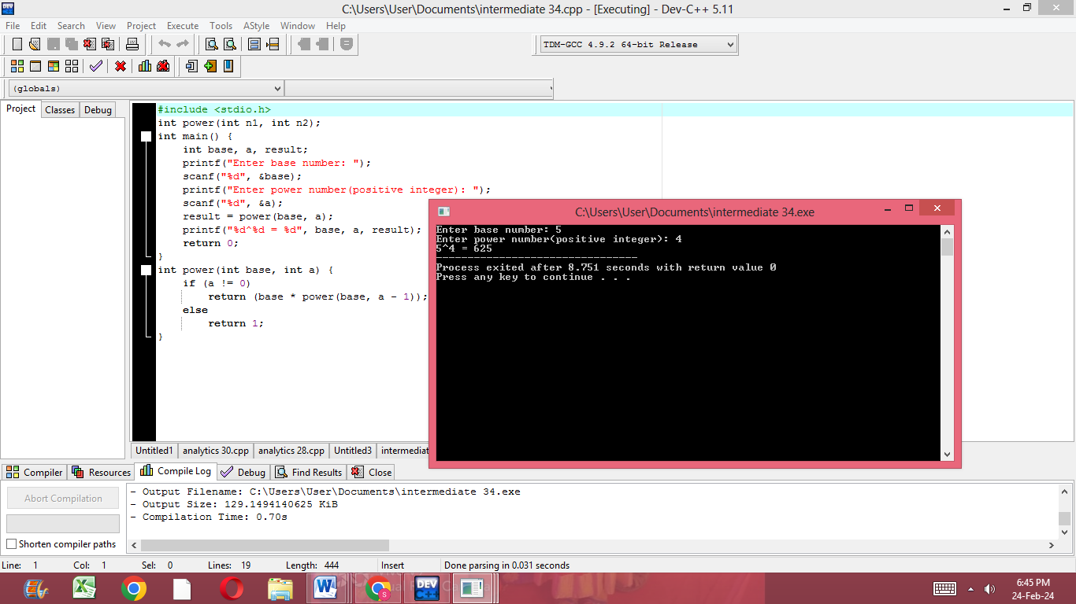

ANALYTICS:

21.Write a C program to implement a function that calculates the area of a triangle given its three sides.

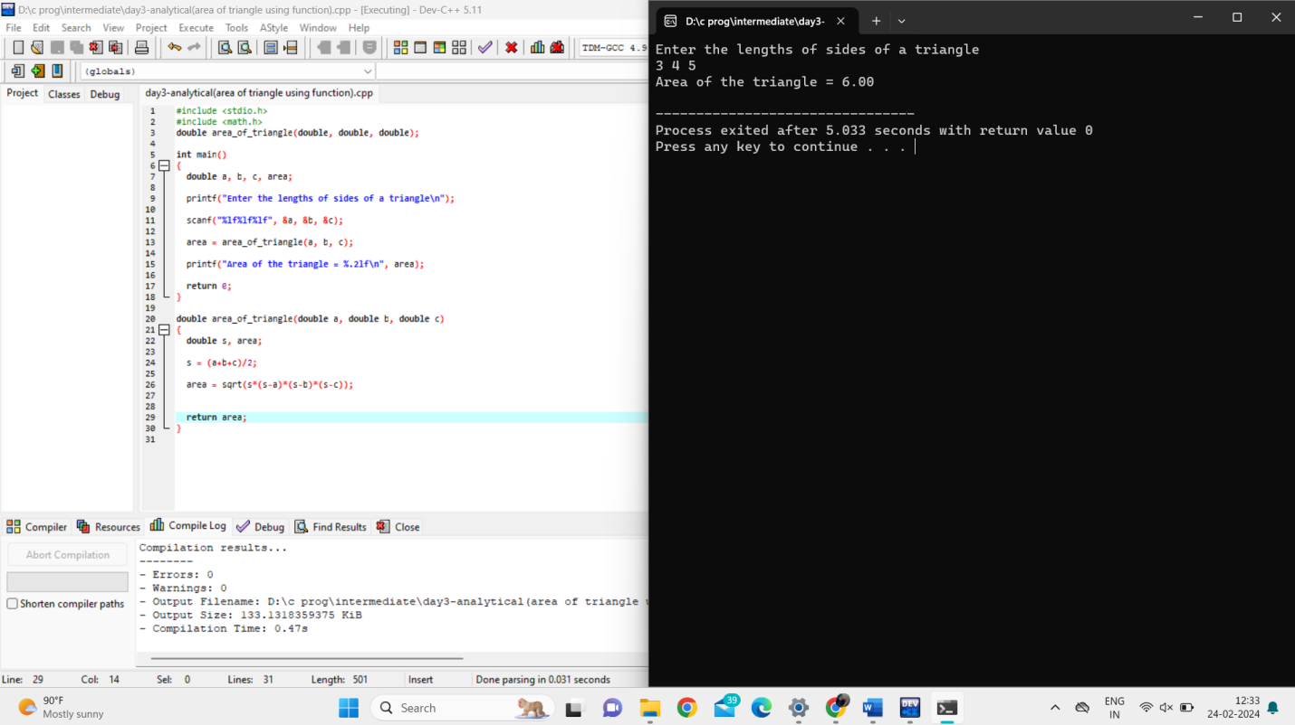

22.Write a C program to implement a function that checks whether a given year is a leap year or not.

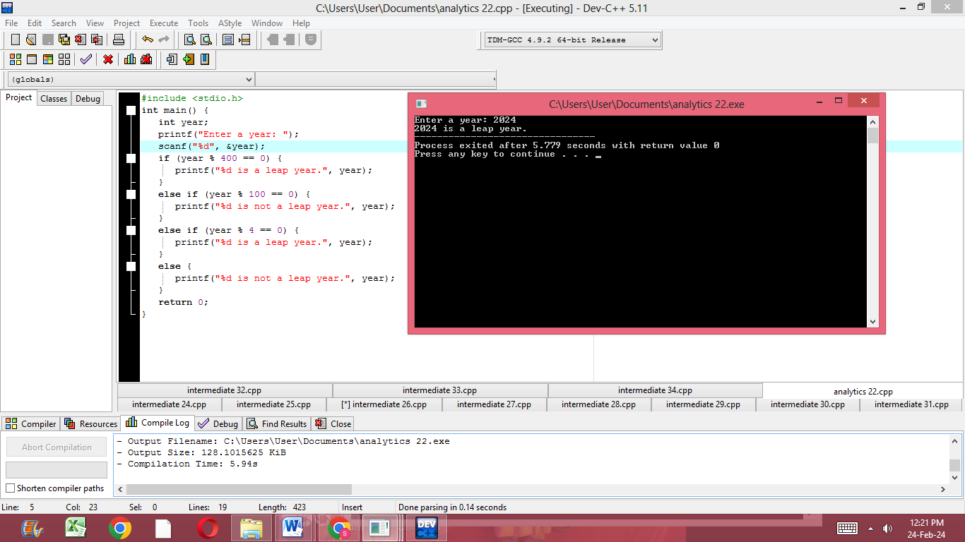

23.Write a C program to implement a function that converts a temperature from Celsius to Fahrenheit and vice versa.

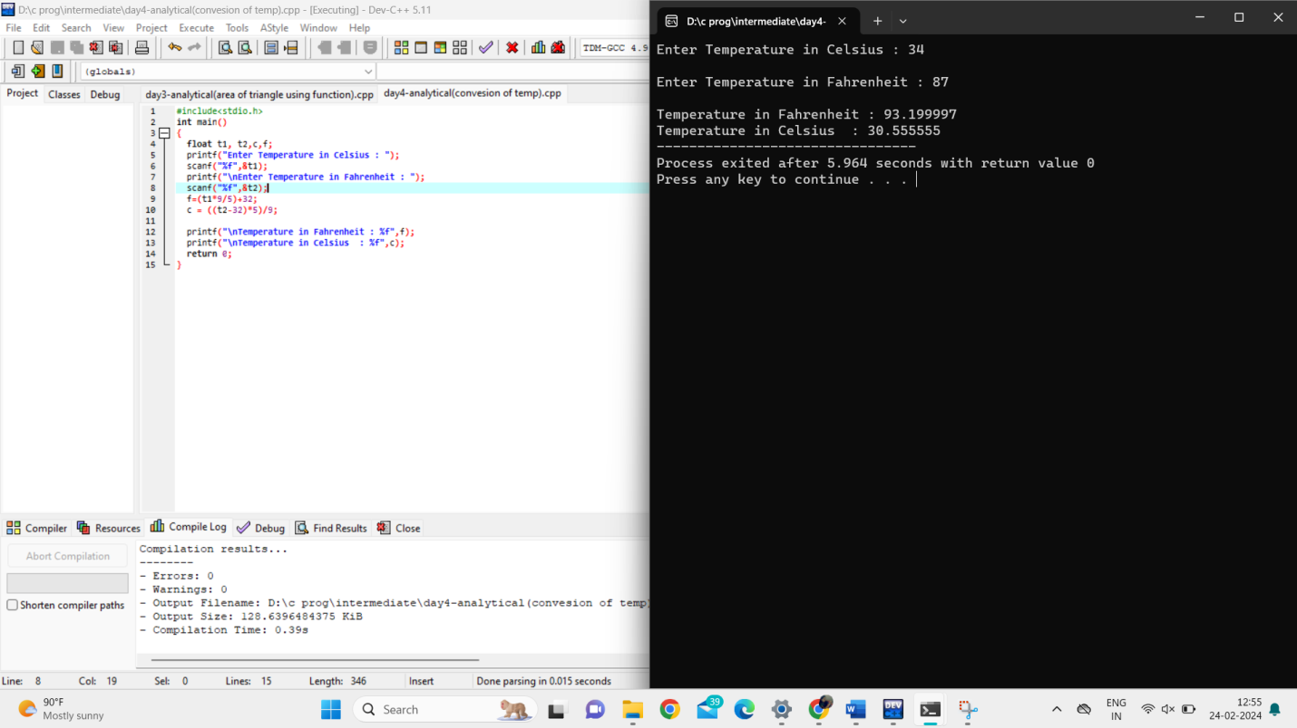

24.Write a C program to implement a function that calculates the factorial of a given number using recursion.

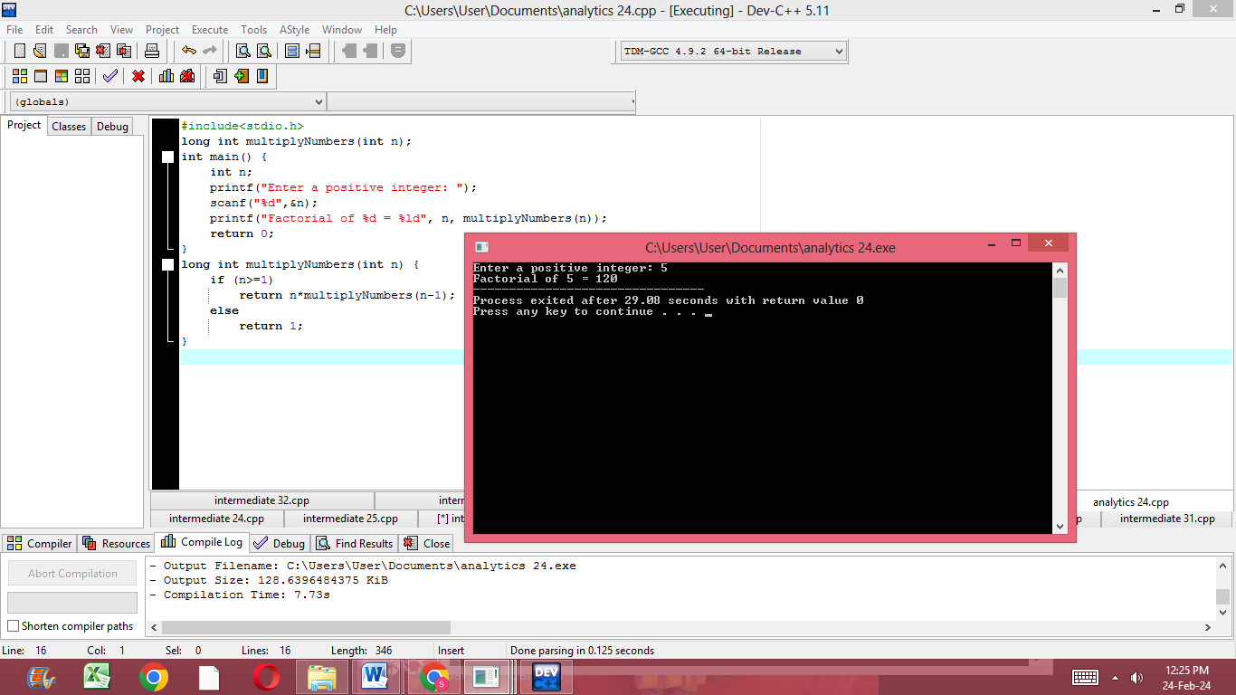

27.Write a C program to implement a function that finds the roots of a quadratic equation ax^2 + bx + c = 0.

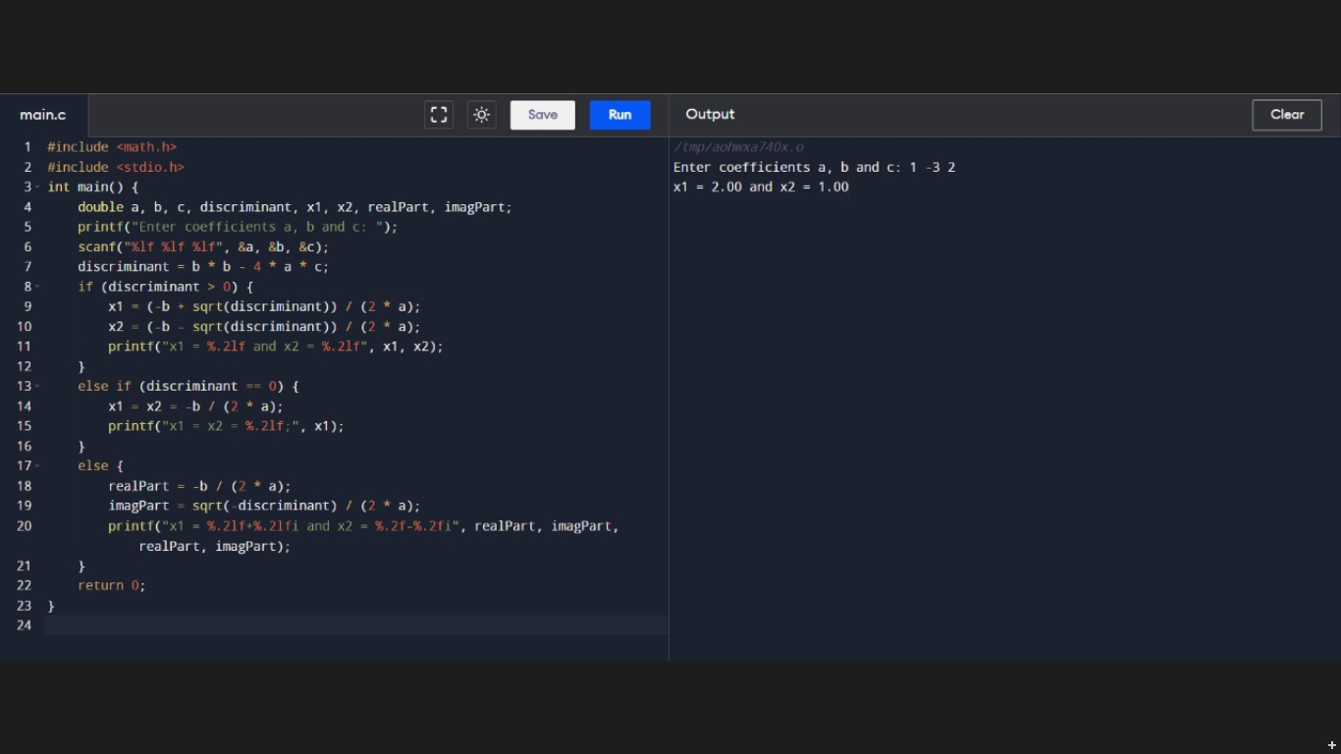

28.Write a C program to implement a function that checks whether a given string is a valid email address or not**.**

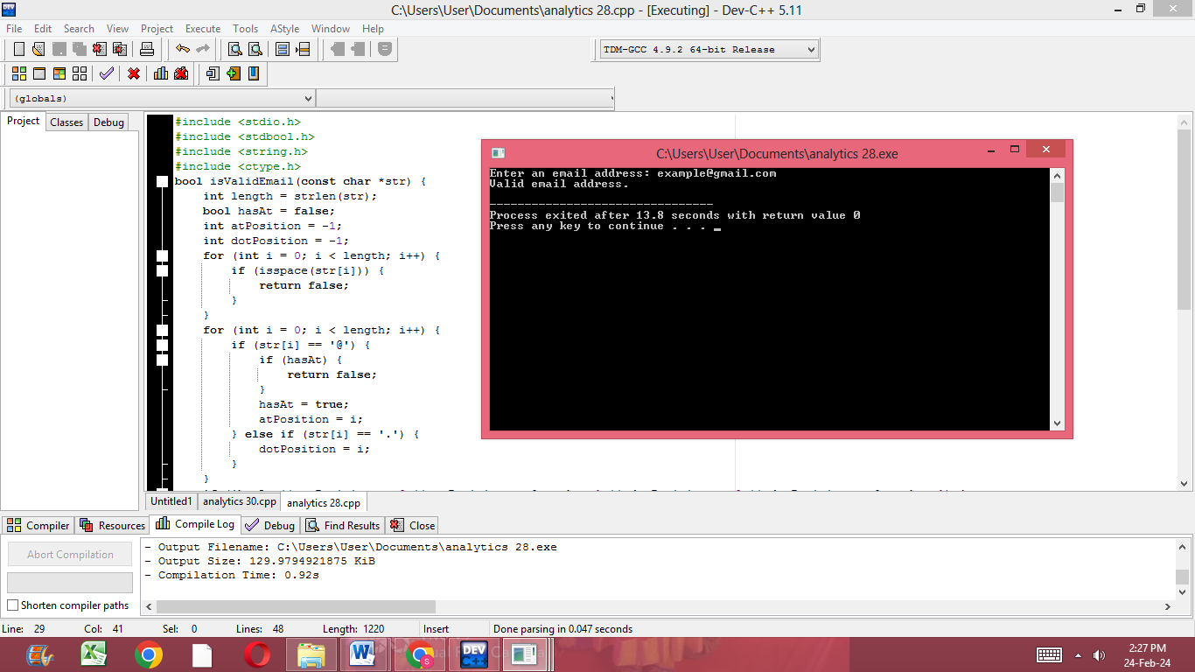

29.Write a C program to implement a function that calculates the sum of digits of a given number until it becomes a single-digit number (digital root).

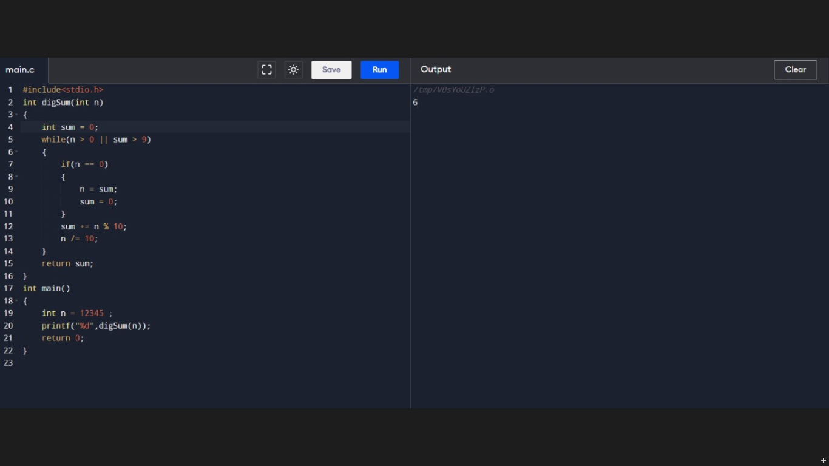

30.Write a C program to implement a function that checks whether a given number is a palindrome or not without converting it to a string.

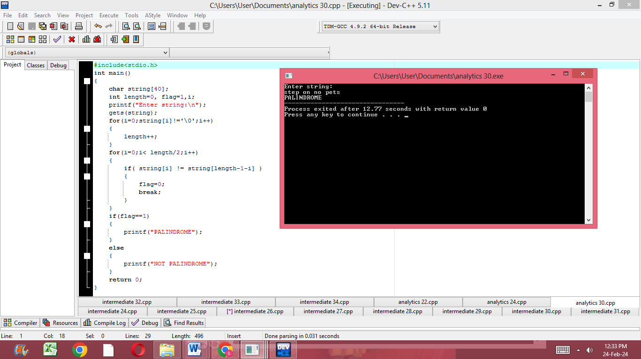

32.Write a C program to implement a function that checks whether a given string is a valid palindrome ignoring spaces, punctuation, and capitalization.

